Pneumonia Detection via Image Recognition Documentation on Chest x-rays

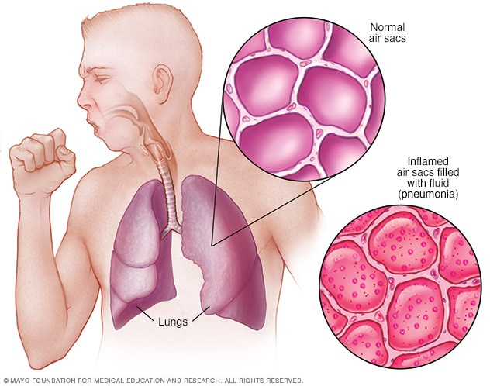

Dean Stokeld

Capstone Project

19/04/2022

Contents

Introduction 3

Process overview 3

Problem statement 3

Business Question 4

Data Question 4

Data science process 4

Model architechure 5

Modelling 5

Outcomes 5

Data answer 5

Business answer 5

End-to-end solution 6

References 6

Introduction

Pneumonia is an infection that inflames the air sacs in one or both lungs. The air sacs may fill with fluid or pus (purulent material), causing cough with phlegm or pus, fever, chills, and difficulty breathing. A variety of organisms, including bacteria, viruses, and fungi, can cause pneumonia. Pneumonia can range in seriousness from mild to life-threatening. It is most serious for infants and young children, people older than age 65, and people with health problems or weakened immune systems.

Process Overview

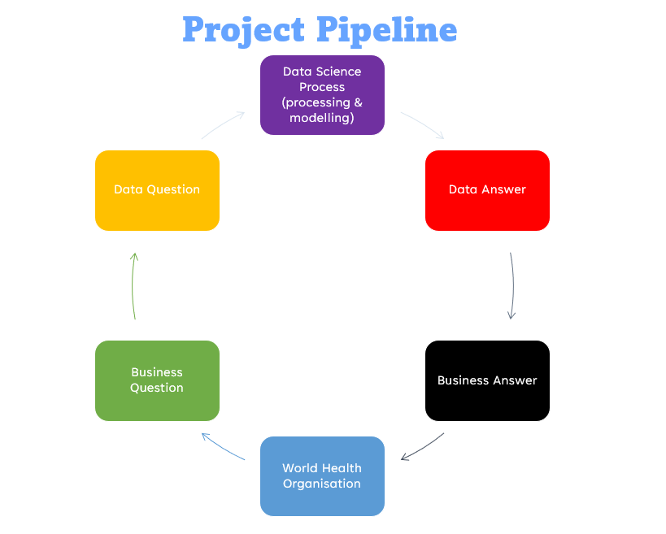

Problem Statement

Patients are forced to wait until x-rays are manually looked at for diagnosis of health conditions, this wait may be from hours to days. The time it takes for medical treatment may allow the condition to worsen, in this case, pneumonia.

Business Question

“How can we detect the presence of pneumonia in chest x-rays immediately to reduce the time it takes for a patient to receive a diagnosis & appropriate medical attention?”

Data Question

“How can we use artificial intelligence to detect the presence of pneumonia on an x-ray?”

Data Science Process

Data Extraction

* Images were gathered from a published online dataset by the University of California, San Diego.

Image Preprocessing

* Images were resized to 256x256 pixels to use less computational power.
* Normalisation images by 255 to reduce variance in pixel.

Model Architecture

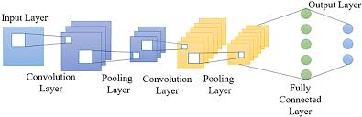

Modelling

* Model took 12 hours of training
* Model was trained on Windows 11 OS with a single GPU
* Total loss graph indicated on both models was between 0.15 to 0.33.
* Compared pre-trained models: VGG19 with ResNet50V2.

Outcome

* Models predicted with high accuracies.

Data Answer

* Use image recognition using artificial intelligence and accurate detect pneumonia on chest x-rays.

Business Answer

* Reduce the time it takes for a patient to receive a diagnosis.

End-to-end solution

* We are not making doctors redundant as they still provide vital health care with personal recommendations that this model does not do.
* Incorporate model directly into every CT machine.

References

Data source: <https://data.mendeley.com/datasets/rscbjbr9sj/2>

Articles: <https://www.nhlbi.nih.gov/health/pneumonia>

<https://www.ncbi.nlm.nih.gov/books/NBK526116/>

https://thorax.bmj.com/content/56/4/296

https://www.mayo.edu/research/clinical-trials/diseases-conditions/pneumonia